Graphics Server .NET

New Charting Features for Version 3.5

August 15, 2006
Table of Contents

1 New MinorGridLinesOn Property and MinorGridLineProperties Property 3
2 New AxisRadar.SpokeEvery Property 3
3 New SetDataPointSymbol() and GetDataPointSymbol() override methods 4
4 Enhanced Marker Labels to support all 3D chart types 4
5 Enhanced ToolTips to work for Windows Forms 5
6 Recommended Usage: Font.Dispose when accessing Font in code 5
7 Bug Fixes and Other Enhancements 5
7.1 New chart constructor Chart(width, height) 6
7.2 Added Dispose() methods to all necessary System.Drawing objects 6
7.3 Widget Events now fire correctly 6
7.4 Fixed Style Designer behaving erratically (most notably in Visual Studio 2005) 6
7.5 Chart and Widget Export new minimum size of 1 x 1 images 6
7.6 Web Control’s DeleteASPNetTempFileMode.OnlyWebControlFiles fixed 6
7.7 New AxisX and AxisY DrawingOrigin Property fixes Trend Lines and Date-Time axis 6
7.8 Default Chart Wizard templates no longer have Chart Title text 7
7.9 Widget – Slider’s scale outline working correctly 7
7.10 TextFormat HorizontalAlignment now serializes correctly 7
7.11 Fixed same image when multiple charts dropped onto Web Form 7
7.12 Web Chart hidden data points do not show ToolTip 7
7.13 Bubble 2D ToolTips work correctly 7
7.14 AxisX and AxisY’s AxisPosition = Variable now works better 7
7.15 Fixed wrong size (width/height) when Chart / Widget saved to EMF/WMF file 8
7.16 Fixed bug with incorrect y-axis min and max for Stacked Combination charts 8
7.17 Fixed incorrect legend icon for combination Stacked Area + Line chart 8
7.18 MinorTicks needs Axis.DrawingOrigin=StartZero for very large axis range (also DateTime axis) 8
7.19 Bar2DHorizontal fixed to always start point #0 at top 8
7.20 Bug with RunTimeDir = Images fixed 8
7.21 Fixed 3D Grid Lines displaying in wrong location 8
7.22 Fixed Property Page – Axis Tab to support greater Min/Max/TickInterval values 8
7.23 Axis3DX, Axis3DY, and Axis3DZ now support MinorTicks Property 9
7.24 Web Image Map (ToolTips) work in IE, FireFox 9
7.25 Fixed Web Image Map when in Bytestream mode 9
7.26 New ByteStreamPageMode applies when Web ImageFileMode = Bytestream 9
7.27 Fixed Chart.RemoveAllSeries to remove series and labels from the Chart Wizard 9

New MinorGridLinesOn Property and MinorGridLineProperties Property
Minor Grid Lines have been added to all the linear chart types (does not apply to Radar, Funnel, etc). Minor Grid Lines will be drawn from the MinorTicks, spanning the axis length. One can enable these by setting the MinorTicks to 1 or greater, enabling them using MinorGridLinesOn and setting the visual color and thickness using MinorGridLineProperties. In the example below, both the Axis3DX and the Axis3DY have MinorTicks > 0, MinorTicksOn = True, and have the MinorGridLinesProperties Color set to LightGray. Also in the image the GridLines (for the major ticks) are on and colored Black.
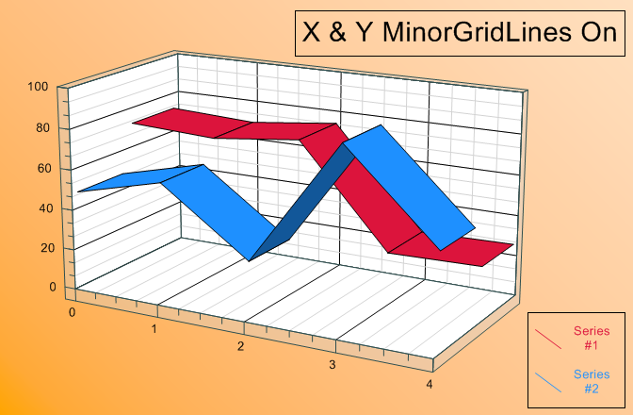

New AxisRadar.SpokeEvery Property
The new SpokeEvery property for the Radar chart allows only some of the spokes to be displayed. Previously all the spokes (for every data point) were displayed. In the example image below SpokeEvery = 10, which hides every 9 spokes and only displays every 10th spoke.
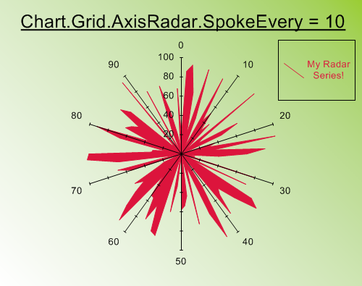

New SetDataPointSymbol() and GetDataPointSymbol() override methods
One can now override individual symbols within the same series using the SeriesDrawing.SetDataPointSymbol method. And you can retrieve the symbol for a given data point using the SeriesDrawing.GetDataPointSymbol method. In the example image below, the third data point’s symbol has been overridden with a large green upside-down triangle.
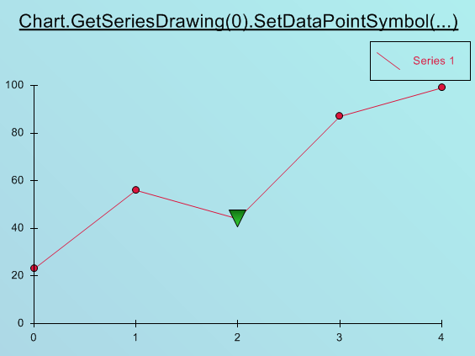

Enhanced Marker Labels to support all 3D chart types
Previously when you set each SeriesDrawing.MarkerLabelsOn property (or use SeriesDefaults.MarkerLabelsOn) this only applied to 2D chart types. Now all 3D chart types also support marker labels, including overriding each label with your own custom label using SeriesDrawing.SetUserMarkerLabel. The below example has marker labels turned on using SeriesDrawing.MarkerLabelsOn = true, and also has the marker label colors assigned from the series color using SeriesDrawing.MarkerLabelProperties.Color = SeriesDrawing.MarkerFill.Color.
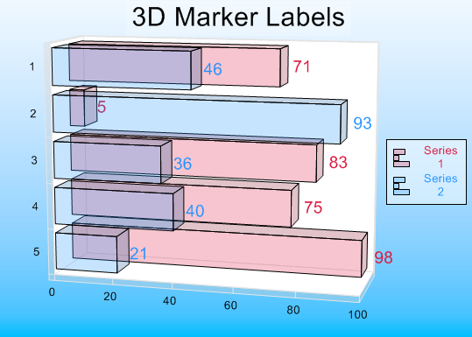

Enhanced ToolTips to work for Windows Forms
The new Windows Forms control properties ToolTipEnabled and ToolTipDuration allow you to add tooltips to your Windows Forms charts. ToolTipEnabled turns tooltips off and on, while the ToolTipDuration allows you to set how long in milliseconds the tooltips will appear for. You can assign custom tooltip text using the SeriesDrawing.SetUserMarkerToolTip() method, which works the same as the Web Form control. Also you can set the Grid.ToolTipText, ChartTitle.ToolTipText, Legend.ToolTipText and Annotation.ToolTipText for the non-date elements of your chart. The example chart below has custom tooltips for the data points, where the custom tooltip equals the SeriesName value plus the DataPoint index plus the DataPoint’s numeric value.
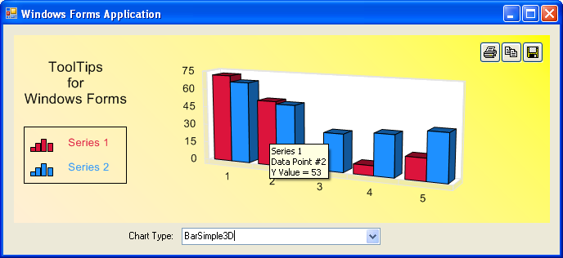

Recommended Usage: Font.Dispose when accessing Font in code
This is a new change in v3.5. Now whenever you set the font or get the font in code you should call Font.Dispose in the same local function that you set or get the Font. For example, you can set the chart title’s font like this:

private void Form1_Load(object sender, EventArgs e)
{
// Get chart reference.
Chart chart = this.gsNetWinChart1.Chart;

// Set chart title font.
chart.ChartTitle.TextFormat.Font = new Font("Comic Sans MS", 14);
// Should call dispose after using Font property in code.
chart.ChartTitle.TextFormat.Font.Dispose();
}

This sample creates a new Font object stored in the TextFormat.Font property. Like many classes in System.Drawing, the Font should be Disposed when you are done using it. Internally the font information is saved, so disposing the Font sometime later in the local Form1_Load function is recommended. Our example Disposes the Font immediately in the following line, which is okay.

Bug Fixes and Other Enhancements

New chart constructor Chart(width, height)
A new, overloaded, chart constructor has been added. So one can now initialize a Chart object with a width and height: Chart(300, 200) would create a new chart with a width of 300 and a height of 200.

Added Dispose() methods to all necessary System.Drawing objects
As per the Microsoft documentation, most of the System.Drawing classes require that Dispose() be called on the objects once you are done using them. Dispose(), or the equivalent using( …) statement, has been added to all the necessary System.Drawing objects in the so urce code. This code change does not require the user/consumer of the chart or widget control to call Dispose(), instead it is completely internalized and invisible to the user/consumer.

Widget Events now fire correctly
Previously the Widget events did not get fired at all. Now the widget events MouseClickWidgetEvent, MouseHoverWidgetEvent, MouseMoveWidgetEvent, and MouseWheelWidgetEvent fire correctly when the mouse is clicked, hovered, moved, or wheeled, respectively.

Fixed Style Designer behaving erratically (most notably in Visual Studio 2005)
The Style Designer had a bug that made it behave erratically. This included some of the controls not getting updated correctly, or some controls hanging and not allowing the user to select and change settings. All bugs are now fixed and the Style Designer behaves without errors and updates the chart with the settings the user chooses.

Chart and Widget Export new minimum size of 1 x 1 images
Previously the Chart and Widget sizes when saving/exporting an image had a minimum of 100 pixels wide by 100 pixels high (a 100 x 100 image minimum). Now the minimum is a 1 pixel wide by 1 pixel high image (a 1 x 1 image minimum). The is set by assigning the Size property (usually setting the Windows Form control’s size or Web Form’s control size) before calling Chart.Export( ) or Widget.Export( ). Note, however, the Windows Form control and Web Form control may have a larger minimum size (such as an 8 x 8 size) in order to be dropped and resized on a Windows Form or Web Form.

Web Control’s DeleteASPNetTempFileMode.OnlyWebControlFiles fixed
In version 3.0 we added a new DeleteASPNetTempFileMode property for the web controls. There was a bug with the OnlyWebControlFiles enumeration that did not delete all the files created by our chart or widget controls. This bug is now fixed and all the files we create will be deleted properly, according to the FilesToDelete and MinutesOld values (same deletion policy as our “Managing Web Image Files” documentation details, except applied to the machine’s ASP.NET Temp folder).

New AxisX and AxisY DrawingOrigin Property fixes Trend Lines and Date-Time axis
A new property has been added to the AxisX and AxisY named DrawingOrigin. This can be a somewhat confusing property, so it is recommended to be left at the “Auto” default setting. The main purpose of DrawingOrigin is to fix the trend lines so they are internally calculated correctly (such as the TrendVariableOrderPolynomial when drawn on a Date-Time X-Axis chart). The fix means that the internal values used to calculate the trend line will start at 0 rather than the actual value of the DateTime.Ticks (which could be, for example, 1 X 10¹⁷). This DrawingOrigin fix now allows the trends to calculate the correct equation for the trend line, since starting at 0 is much less likely to cause floating-point errors in the equation calculations (or overflows in the equation calculations). The DrawingOrigin is available as a public property in case the user happens to have a very large axis minimum and maximum, and in this case the user can set DrawingOrigin.StartZero to get the correct trend lines. Note that with any DrawingOrigin setting, the data appearing on the chart, as well as the axis labels, would look exactly the same.

Default Chart Wizard templates no longer have Chart Title text
Previously the default templates available in the Chart Wizard / Interactive Designer had text for the Chart Title. This has been removed, so that the user can select any template and the Chart Title will not be modified when a new template is selected.

Widget – Slider’s scale outline working correctly
In Graphics Server .NET 3.0 the slider’s scale outline was not working correctly. It was incorrectly offset from the slider scale itself (causing an extra rectangle to be drawn, apart from everything else). This has been correctly and now the slider looks good again.

TextFormat HorizontalAlignment now serializes correctly
The TextFormat properties (which are of type TextPainter) are fixed so the HorizontalAlignment sub-property now correctly serializes and de-serializes. Also note that the AutoAdjustAlignment sub-property must be set to false for the HorizontalAlignment and VerticalAlignment sub-properties to be used, otherwise the alignments will be automatically determined.

Fixed same image when multiple charts dropped onto Web Form
There was an occasional issue of 2 or more chart controls dropped onto a single Web Form displaying the same image in design-time, even when the two charts had differing properties. This has been fixed and now all design-time charts display their own properties correctly.

Web Chart hidden data points do not show ToolTip
Previously, there was a bug with the web chart’s hidden data points when using GetSeriesDrawing().HideDataPoint. Visually the data point was hidden (not drawn), but the ToolTip still appeared for that data point when a user hovered over the data point location. Now the ToolTip is gone, along with no data point being visually drawn, when HideDataPoint is called.

Bubble 2D ToolTips work correctly
The ToolTips's hover area for Bubble 2D charts were too large. This use to result in hovering near the bubble still popped up the tooltip. This has been fixed, so now just hovering over the bubble itself gives you the tooltip, and does not give you the tooltip when you are just close to the bubble.

AxisX and AxisY’s AxisPosition = Variable now works better
Previously when the AxisX.AxisPosition or AxisY.AxisPosition was set to AxisPositionType.Variable the axis would sometimes get hidden for charts with all-positive data or all-negative data. Now this has been fixed so an axis with AxisPosition = Variable will always show the axis. For charts with all-negative values, or charts with all-positive values, the new AxisPosition = Variable will “hug” the appropriate side of the Grid - left, right, top or bottom - and still remain visible.

Fixed wrong size (width/height) when Chart / Widget saved to EMF/WMF file
Previously when the Chart.Export or Widget.Export was called to save an EMF file type or WMF file type, the saved image width and height did not always equal the Chart/Widget’s width and height. This has been fixed, so now the EMF/WMF file’s width and height always matches the Chart/Widget’s width and height.

Fixed bug with incorrect y-axis min and max for Stacked Combination charts
Fixed bug with an incorrect y-axis min & max with combination charts (stacked bars + lines, or stacked areas + lines, etc). Now the correct y-axis min and max are created by default, so all combination series will fit within the chart's min y and max y values.

Fixed incorrect legend icon for combination Stacked Area + Line chart
Previously for a Stacked Area + Line combination chart, the legend for the line series was incorrect (shown as an area legend instead of a line legend). This has been fixed, so the stacked area legends show as area icons and the line legends show as line icons.

MinorTicks needs Axis.DrawingOrigin=StartZero for very large axis range (also DateTime axis)
There is a problem with the MinorTicks not showing up for an axis which has a very large axis range. This also includes DateTime axes, since DateTime axes always have a large axis range (they use DateTime.Ticks values which are very large). The fix for this is to always set the Axis.DrawingOrigin property to StartZero (or you can leave it at Axis.DrawingOrign = Auto for DateTime axis). This setting will make the MinorTicks appear correctly. Note that the DrawingOrigin property is new to GS.NET v3.5.

Bar2DHorizontal fixed to always start point #0 at top
The Bar2DHorizontal axis is ordered with point #0 at the top, point #1 second from top, point #2 third from top, and so on. Previously changing the IsGapAligned property resulted in incorrect ordering (reverse ordering) of the Bar2DHorizontal points. This is fixed so now a Bar2DHorizontal chart always starts with point #0 at the top, no matter if IsGapAligned is true or false.

Bug with RunTimeDir = Images fixed
Previously you could not name the web control’s run time directory the name “Images”. Previously this resulted in no image getting created and a broken link (red X) on the web page. This has been fixed, so now the RunTimeDir can be named “Images” and an image is correctly created and displayed in the web browser.

Fixed 3D Grid Lines displaying in wrong location
Previously the 3D X Axis grid lines displayed incorrectly for horizontal 3D bar charts. And the 3D Z Axis grid lines displayed incorrectly when there were negative values on the 3D chart. These have been corrected and now the 3D grid lines display correctly in all situations.

Fixed Property Page – Axis Tab to support greater Min/Max/TickInterval values
Previously the Axis Tab in the Property Pages would error out if the MinAxisValueUser, MaxAxisValueUser, or MajorTickInterval properties of an axis exceeded (+/-) 1,000,000,000 (1 Billion). This has now been increased to the maximum value of a Decimal, which is (+/-) 79,228,162,514,264,337,593,543,950,335. This fixes cases with very large axis values. It also fixes the x-axis when it’s in DateTime mode.

Axis3DX, Axis3DY, and Axis3DZ now support MinorTicks Property
Previously no MinorTicks appeared for 3D charts, even when MinorTicks was 1 or greater. Now MinorTicks appear when set to a value of 1 or greater.

Web Image Map (ToolTips) work in IE, FireFox
Added a new tag TITLE, in addition to the ALT tag that will enable the Image Map for both IE and FireFox. Previously this only work in IE because previously only the ALT tag was used.

Fixed Web Image Map when in Bytestream mode
Previously there was a bug with the image map when using ImageFileMode = ByteStream. This has been fixed and the image map and tooltips should work correctly for the visible data.

New ByteStreamPageMode applies when Web ImageFileMode = Bytestream
A new web property ByteStreamPageMode applies only when the ImageFileMode property equals ByteStream. Then one can either set the ByteStreamPageMode to RelativeUrl which uses a relative web path, or the ByteStreamPageMode can be set to AbsoluteUri to use a absolute web path. Toggling to one setting or the other can be useful for getting the image files to show up with various web server configurations.

Fixed Chart.RemoveAllSeries to remove series and labels from the Chart Wizard
There was a minor bug that did not remove the series and x-axis labels, that were assigned via the Chart Wizard, when calling the Chart.RemoveAllSeries method. This has been fixed, so now all series and labels are removed when calling the RemoveAllSeries method.

